Project Proposal

**Title: Railway Management System**

Object Oriented Programming 1 (Java)

Section: B

**Group Members**

Ahmed, Niaz : 15-28535-1

Mamun,Ashraf : 15-28236-1

Nawshin,Nusrat : 15-28519-1

**Railway Management System**: This is will be a complete software based solution for the railway authority to operate without any pen and paper. There will be different group of user having different level of access and features in the system.

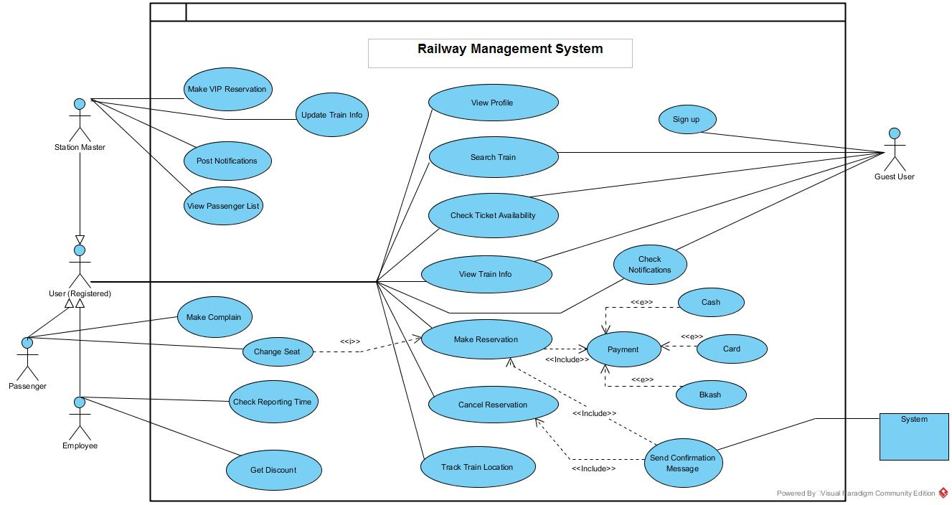**Use Case Scenario**